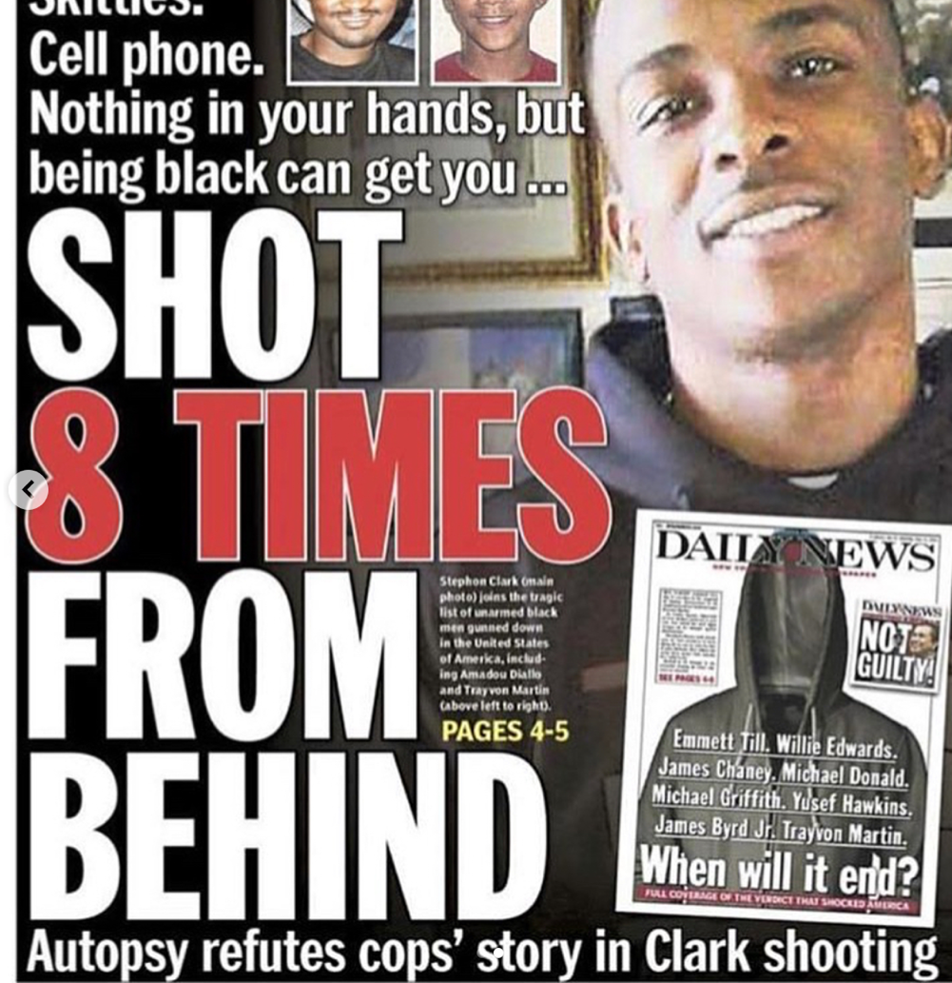
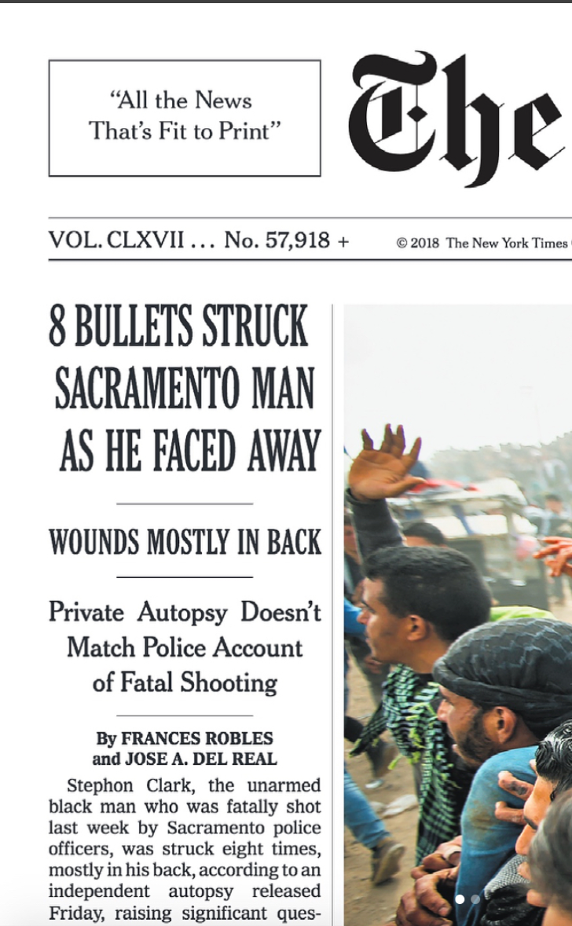
Bell: Passive voice. Passive voice is sometimes referred to as “past exonerative” because it is meant to absolve the speaker of a direct admission. It’s the same as “mistakes were made”. In fact, Wikipedia provides a perfect definition: "Mistakes were made" is an expression that is commonly used as a rhetorical device, whereby a speaker acknowledges that a situation was handled poorly or inappropriately but seeks to evade any direct admission or accusation of responsibility by not specifying the person who made the mistakes. The acknowledgement of "mistakes" is framed in an abstract sense, with no direct reference to who made the mistakes. A less evasive construction might be along the lines of "I made mistakes" or "John Doe made mistakes." The speaker neither accepts personal responsibility nor accuses anyone else.
NY Times: Who shot him? From whom was he facing?
Q: What’s wrong with this title?
The Daily News article headline is an example of passive voice. It fails to mention the shooter is a police officer.

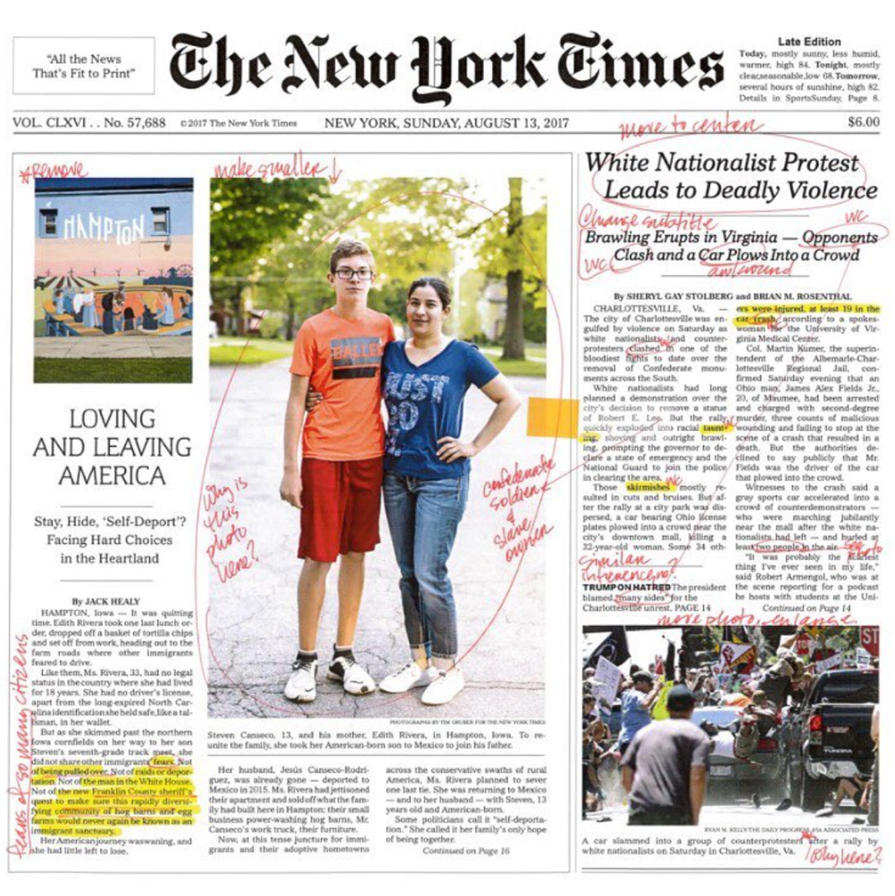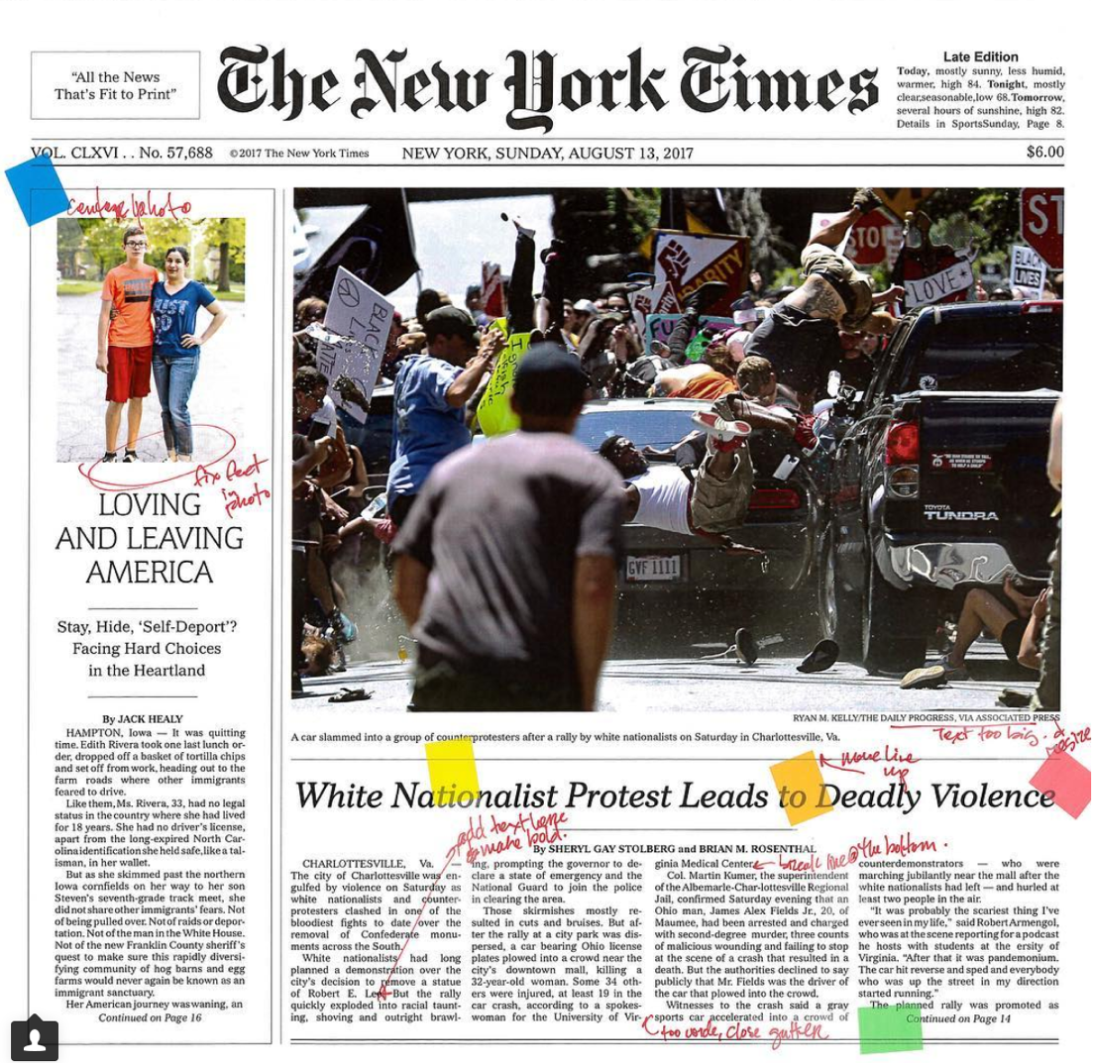

“There are these subtle ways that racism works in the oldest of institutions,” she continues. One moment in the video shows Bell discussing the “Unite the Right” rally that took place in Charlottesville, Virginia, last August. “I’m thirty-five. I’ve never seen a torch rally,” she says. She demurs that she suspected that the Times would screw up coverage of the event in some way. It ended up being the layout. Bell knows to anticipate soft bigotries even in elements like design. “The problem here was the layout,” she says. “It was a side-piece . . . The layout doesn’t speak to the severity of these issues.”

“I am really trying to see if I can disrupt subliminal messaging about who should be valued,” she says.

